**Assignment (Programming) - 2**

**COMP 410 A – SP24 - Due on 18th May 2024, 11:59 PM**

**Hafsah Shahbaz – 251684784**

PART A:

**Regions Classification**

1. **A part**:
   * **Explanation**: This region includes points where xx is positive and yy is greater than or equal to xx. It also includes the origin point (0,0)(0,0).
   * **Boundary Handling**: If y=xy=x, the point is included in the A part.
2. **B part**:
   * **Explanation**: This region includes points where xx is positive and yy is non-negative but less than xx.
   * **Boundary Handling**: Points exactly on the line y=0y=0 are included in this region.
3. **C part**:
   * **Explanation**: This region includes points where xx is positive and yy is negative and less than or equal to −x−x.
   * **Boundary Handling**: Points exactly on the line y=−xy=−x are included in this region.
4. **D part**:
   * **Explanation**: This region includes points where xx is positive and yy is negative but greater than −x−x. It also includes points where x=0x=0 and yy is negative.
   * **Boundary Handling**: Points exactly on the line y=−xy=−x but not included in C part are considered here.
5. **E part**:
   * **Explanation**: This region includes points where xx is negative and yy is negative but greater than or equal to xx.
   * **Boundary Handling**: Points exactly on the line y=xy=x are included in this region.
6. **F part**:
   * **Explanation**: This region includes points where xx is negative and yy is negative and less than xx. It also includes points where xx is negative and y=0y=0.
   * **Boundary Handling**: Points exactly on the line y=0y=0 with xx negative are included here.
7. **G part**:
   * **Explanation**: This region includes points where xx is negative or zero and yy is positive but less than or equal to −x−x.
   * **Boundary Handling**: Points exactly on the line y=−xy=−x are included in this region.
8. **H part**:
   * **Explanation**: This region includes points where xx is negative or zero and yy is positive and greater than −x−x.
   * **Boundary Handling**: Points exactly on the line y=−xy=−x but not included in G part are considered here.

#### Sequential Execution

The sequential execution reads each coordinate from the file and determines the region for each point using conditional statements. The code iterates through all 10,000,000 points, checking each coordinate against the defined regions' conditions and counting the points accordingly.

#### Parallel Execution

For the parallel execution, we divided the coordinate points into smaller chunks and processed them concurrently using Python's multiprocessing module. Each chunk was processed by a separate worker, and the results were combined at the end.

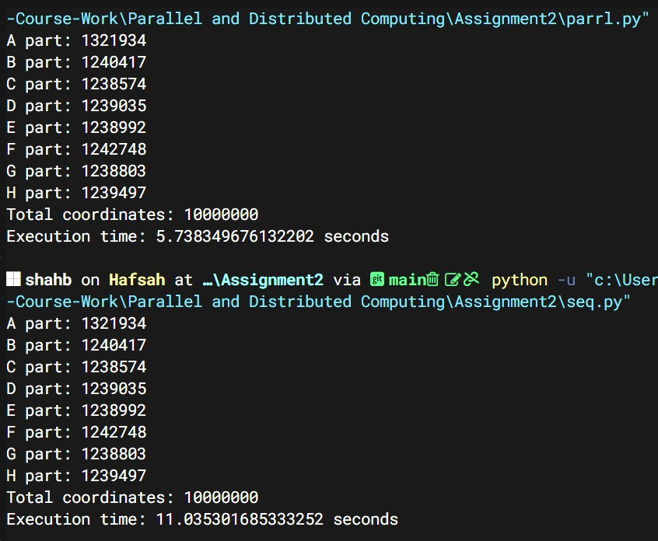

#### Speedup Analysis

The observed speedup can be calculated using the following formula:  
Speedup = Tsequential / Tparallel

Using the given times:   
Speedup = 11 seconds / 5.7 seconds ≈ 1.93

Amdahl's Law states that the speedup of a task using multiple processors in parallel computing is limited by the sequential fraction of the task.

(let's assume P ≈ 0.8)

N = 12

S=1 / [ (1−0.8) + 0.8 / 12 ] ≈ 3.75